Prijavni list
seminar za voditelje „relaksacija smijehom-yoga smijeha“ 23. i 24.11.2024.g.

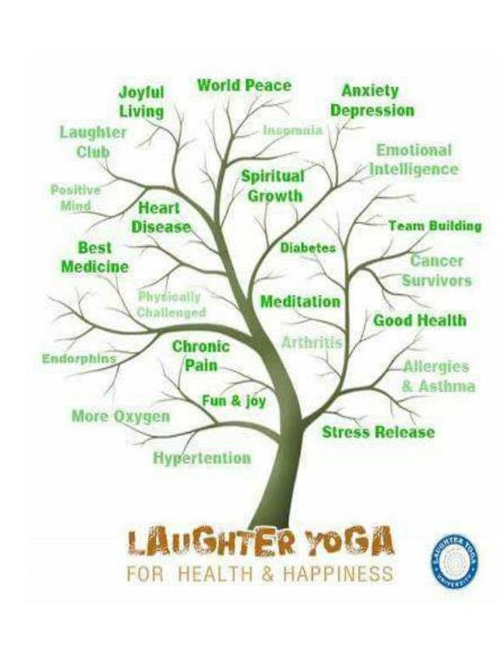

Ime i prezime:_______________________________________________________________

God.rođenja:___________________ OIB:________________________________________

Adresa:_____________________________________________________________________

Tel/mob.:______________________ mail:____________________________

Zanimanje:__________________________________________________________________

Interesi:_____________________________________________________________________

Motiv za prijavu na seminar:____________________________________________________________________

Datum:________________________



